Please check out our extensive online offering to support you with “learning as a family” in 2022

All of our sessions/courses are FREE, either online or within our local centres (following current Government COVID guidelines) and are available to anyone living in Essex, caring or with parental responsibility for a child under the age of 18.

Please feel free to share this with family and friends that you feel would benefit.

Monday 17th January 2022
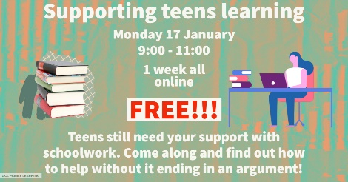 | FL Supporting teens learning  Monday 17/01/2022  (just this session)  09:00-11:00  Delivered online | Teens still need your support with schoolwork. Come along and find out how to help without it ending in an argument! | To book:  https://tinyurl.com/Supporting-teens-learning
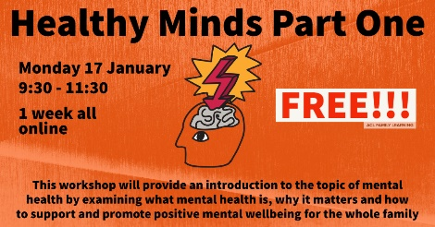 | FL Healthy Minds Part 1  Monday 17/01/2022  (just this session)  09:30-11:30  Delivered online | This workshop will provide an introduction to the topic of mental health by examining what mental health is, why it matters and how to support and promote positive mental wellbeing for the whole family | To book:  https://tinyurl.com/Healthy-Minds-Pt1
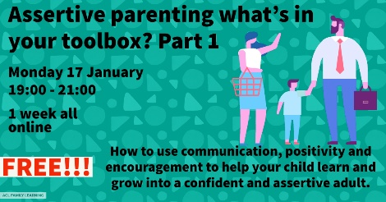 | FL Assertive Parenting Toolbox Part 1  Monday 17/01/2022  (just this session)  19:00-21:00  Delivered online | How to use communication, positivity and encouragement to help your child learn and grow into a confident and assertive adult. | To book:  https://tinyurl.com/Assertive-Parenting-Pt1

Tuesday 18th January 2022
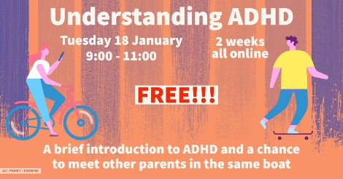 | FL Understanding ADHD  Tuesday 18/01/2022  (delivered over 2 weeks)  09:00-11:00  Delivered online | A brief introduction to ADHD and a chance to meet other parents in the same boat | To book:  https://tinyurl.com/Understanding-ADHD
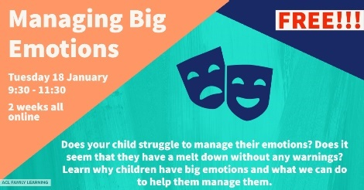 | FL Managing Big Emotions  Tuesday 18/01/2022  (delivered over 2 weeks)  09:30-11:30  Delivered online | Does your child struggle to manage their emotions? Does it seem that they have a melt down without any warnings? Learn why children have big emotions and what we can do to help them manage them. Learn to identify the warning signs and how to get our children to recognise them. A great course full of tips to help your child remain calm. | To book:  https://tinyurl.com/Managing-Big-Emotions-day
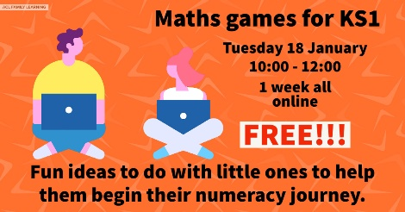 | FL Maths Games for KS1  Tuesday 18/01/2022  (just this session)  10:00-12:00  Delivered online | Fun ideas to do with little ones to help them begin their numeracy journey. | To book:  https://tinyurl.com/Maths-Games-for-KS1
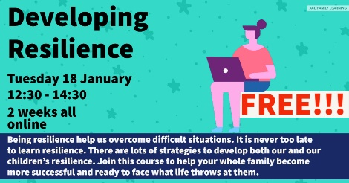 | FL Developing Resilience  Tuesday 18/01/2022  (delivered over 2 weeks)  12:30-14:30  Delivered online | Being resilience help us overcome difficult situations. It is never too late to learn resilience. There are lots of strategies to develop both our and our children's resilience. Join this course to help your whole family become more successful and ready to face what life throws at them. | To book: https://tinyurl.com/Developing-Resilience-Jan22

Wednesday 19th January 2022
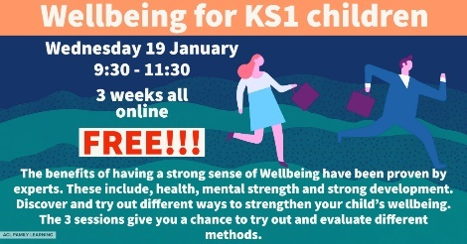 | FL Wellbeing for KS1  Wednesday 19/01/2022  (delivered over 3 weeks)  09:30-11:30  Delivered online | The benefits of having a strong sense of Wellbeing have been proven by experts. These include health, mental strength and strong development. Discover and try out different ways to strengthen your child's wellbeing. The 3 sessions give you a chance to try out and evaluate different methods. | To book:  https://tinyurl.com/Wellbeing-for-KS1
 | FL This is your year  Wednesday 19/01/2022  (delivered over 10 weeks)  09:30-14:30  Delivered online | An opportunity to be in control of shaping your employment choices so that 2022 is your year. This is not just a course looking at employability skills but allowing you the chance to harness the skills you already have, develop others and realise your true potential. A new programme to empower individuals to build their skills and knowledge to enhance life skills and life chances. | To book an assessment: https://tinyurl.com/This-is-Your-Year-2022
 | FL Practical Reading Everyday for KS2  Wednesday 19/01/2022  (just this session)  09:30-11:30  Delivered online | This course is going to give you the confidence to support your child with their English learning. It will give you the current information on what your child will learn in KS2, explain any jargon used and give you practical tips on making English fun. | To book:  https://tinyurl.com/Practical-Reading
Thursday 20th January 2022
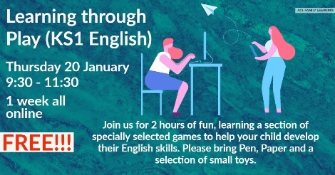 | FL Learning through Play (KS1)  Thursday 20/01/2022  (just this session)  09:30-11:30  Delivered online | Join us for 2 hours of fun, learning a section of specially selected games to help your child develop their English skills. Please bring Pen, Paper and a selection of small toys. | To book: https://tinyurl.com/Learning-through-play-Ks1

Thursday 20th January 2022 continued……
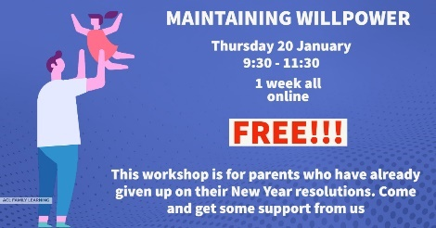 | FL Maintaining Willpower  Thursday 20/01/2022  (just this session)  09:30-11:30  Delivered online | This workshop is for parents who have already given up on their New Year resolutions. Come and get some support from us | To book:  https://tinyurl.com/Maintaining-Willpower
 | FL Fussy Eaters  Thursday 20/01/2022  (delivered over 2 weeks)  10:00-12:00  Delivered online | Fed up with mealtime stress? Want to know what to cook and how to entice fussy eaters to the table? Join us to discuss and get ideas on how to get your little ones eating a wider range of foods. | To book:  https://tinyurl.com/Fussy-Eaters-Jan22
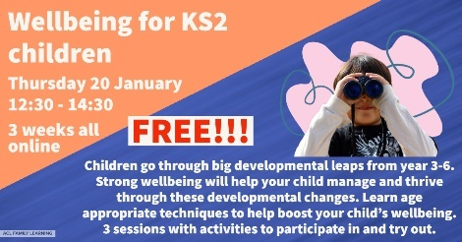 | FL Wellbeing for KS2 children  Thursday 20/01/2022  (delivered over 3 weeks)  12:30-14:30  Delivered online | Children go through big developmental leaps from year 3-6. Strong wellbeing will help your child manage and thrive through these developmental changes. Learn age-appropriate techniques to help boost your child's wellbeing. | To book:  https://tinyurl.com/Wellbeing-for-KS2
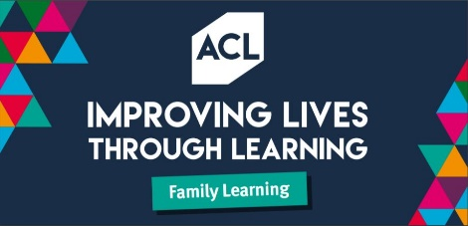 | FL Motivating your family  Thursday 20/01/2022  (just this session)  19:00-21:00  Delivered online | Motivational tips to get your family through the winter months. Includes goal setting and methods to keep up momentum. Future coaching sessions on offer to help keep you and your families motivation. | To book:  https://tinyurl.com/Motivating-your-family-2022

Friday 21st January 2022
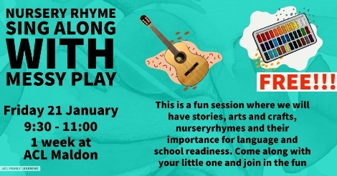 | FL Nursery Rhymes and Messy Play  Friday 21/01/2022  (just this session)  09:30-11:00  Delivered online | This is a fun session where we will have stories, arts and crafts, nursery rhymes and their importance for language and school readiness. Come along with your little one and join in the fun | To book:  https://tinyurl.com/Nursery-Rhymes-21Jan
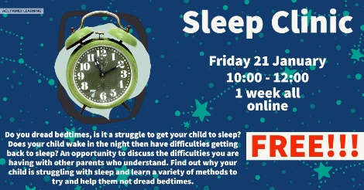 | FL Sleep Clinic  Friday 21/01/2022  (just this session)  10:00-12:00  Delivered online | Do you dread bedtimes, is it a struggle to get your child to sleep? Does your child wake in the night then have difficulties getting back to sleep? An opportunity to discuss the difficulties you are having with other parents who understand. Find out why your child is struggling with sleep and learn a variety of methods to try and help them not dread bedtimes. | To book:  https://tinyurl.com/Sleep-Clinic-Jan
Monday 24th January 2022
 | FL Building Emotional Intelligence  Monday 24/01/2022  (delivered over 2 weeks)  09:30-11:30  Delivered online | Emotional intelligence is just as important as academic. Learn how to help your children strengthen theirs and yours | To book:  https://tinyurl.com/Building-Em-Intelligence
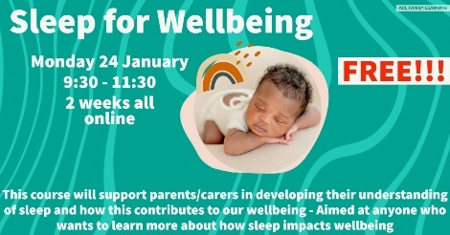 | FL Sleep for Wellbeing  Monday 24/01/2022  (delivered over 2 weeks)  09:30-11:30  Delivered online | This course will support parents/carers in developing their understanding of sleep and how this contributes to our wellbeing - Aimed at anyone who wants to learn more about how sleep impacts wellbeing | To book:  https://tinyurl.com/Sleep-for-wellbeing

Monday 24th January 2022 continued….
 | FL Assertive Parenting Part 2  Monday 24/01/2022  (just this session)  19:00-21:00  Delivered online | Using choice and consequences to help children learn and to promote being an “assertive” parent. | To book:  https://tinyurl.com/Ass-Parenting-Toolbox-Pt2
Tuesday 25th January 2022
 | FL Separation Anxiety workshop  Tuesday 25/01/2022  (just this session)  09:30-11:30  Delivered online | What separation anxiety is, how it affects children and how to effectively manage it. | To book:  https://tinyurl.com/Sep-Anxiety-Jan-22
Wednesday 26th January 2022
 | FL Feeling Yes, Feeling NO!  Wednesday 26/01/2022  (just this session)  12:30-14:30  Delivered online | Our instincts are there for a reasons - to keep us safe. Learn how to help your child recognise their instincts and develop the skills to use them to their benefits. We raise our children to be polite but it is very important they are able to say NO when they are in a situation they are uncomfortable with. A great 2-hour sessions to help our children stay safe. | To book:  https://tinyurl.com/Feeling-Yes-feeling-No
 | FL Can writing be art and Journaling KS2  Wednesday 26/01/2022  (just this session)  09:30-11:30  Delivered online | This course is going to give you the confidence to support your child with their English learning. It will give you the current information on what your child will learn in KS2, explain any jargon used and give you practical tips on making English fun. | To book:  https://tinyurl.com/Can-writing-be-art

Thursday 27th January 2022 |  |  |  |  |  | To book:
 | FL Learning through Play (KS1 STEM)  Thursday 27/01/2022  (just this session)  09:30-11:30  Delivered online | Lots of fun activities to play with your young children. Do you know that STEM activities help with knowledge of technology and science. Learn and try out some things to try with your children. Please bring oil, water, bicarbonate of soda and food colouring. | To book:  https://tinyurl.com/Learning-through-Play-STEM
 | FL Financial Wellbeing for 2022  Thursday 27/01/2022  (just this session)  09:30-11:30  Delivered online | Are you still paying for Christmas and worrying? Are you dreading the bills coming in? Come and find some useful advice and support. | To book:  https://tinyurl.com/Financial-Wellbeing-2022
 | FL Baby and Toddler Talk  Thursday 27/01/2022  (just this session)  09:30-11:30  Delivered online | A workshop to support you and your family to help understand how to encourage your baby and toddlers communication. When children hear more words, it helps to improve their understanding of language, and increases the number and variety of words that they can understand and use. And it's not just about better language skills. Talking with babies helps their brains develop and can help children do better at school when they're older. This is a LIVE interactive course so you will need to log on at the given time to access the course. | To book:  https://tinyurl.com/Baby-and-Toddler-talk-Jan22
 | FL Managing Big Emotions  Thursday 27/01/2022  (just this session)  18:30-20:30  Delivered online | Does your child struggle to manage their emotions? Does it seem that they have a melt down without any warnings? Learn why children have big emotions and what we can do to help them manage them. Learn to identify the warning signs and how to get our children to recognise them. A great course full of tips to help your child remain calm. | To book:  https://tinyurl.com/Managing-Big-Emotions-eve

Friday 28th January 2022
 | FL Nursery Rhymes and Messy Play  Friday 28/01/2022  (just this session)  09:30-11:00  Delivered online | This is a fun session where we will have stories, arts and crafts, nursery rhymes and their importance for language and school readiness. Come along with your little one and join in the fun | To book:  https://tinyurl.com/Nursery-Rhymes-28Jan
 | FL Financial Wellbeing for 2022  Friday 28/01/2022  (just this session)  09:30-11:00  Delivered online | Are you still paying for Christmas and worrying? Are you dreading the bills coming in? Come and find some useful advice and support. | To book:  https://tinyurl.com/Financial-wellbeing-for-2022

Please feel free to share with anyone else you feel would benefit, living in Essex.

ACL ESSEX also offer adults a wide range of daytime and evening adult learning courses to help you improve your job prospects, learn a new skill or simply inspire you. If you would like someone to contact you, check out our website(www.aclessex.com) and click here.

We also offer FREE sessions in local schools, libraries and community groups that are not listed here. If you would like to host a session, or to find out more please contact us on the details below.

Please visit our website for specific course details or visit our Facebook group and Instagram pages
For more information, please contact us:
Melissa Williamson and Zoe Mallett
Curriculum Leads for Community and Family Learning
Email: melissa.williamson@essex.gov.uk zoe.mallett@essex.gov.uk
Tel: 03330321597 03330321372

