Thriftwood School & College

CCTV Policy

Approved by EC:

Review Date:

Contents
Section Title | Page No.
Introduction | 2
Statement of Intent | 2
Siting the cameras | 3
Covert monitoring | 3
Storage and retention of CCTV images | 3
Access to CCTV images | 4
Subject Access Requests | 4
Access to and disclosure of images to third parties | 4
Complaints | 4
Appendix A: CCTV Signage | 5

CCTV Policy

Introduction

This is Thriftwood’s approved policy relating to the use of CCTV. Thriftwood College uses closed circuit television (CCTV) images to reduce crime and monitor the college buildings in order to provide a safe and secure environment for pupils, staff and visitors, and to prevent loss or damage to the property.

The system comprises a 16-channel system, with 11 cameras in operation, located as shown in the map below:

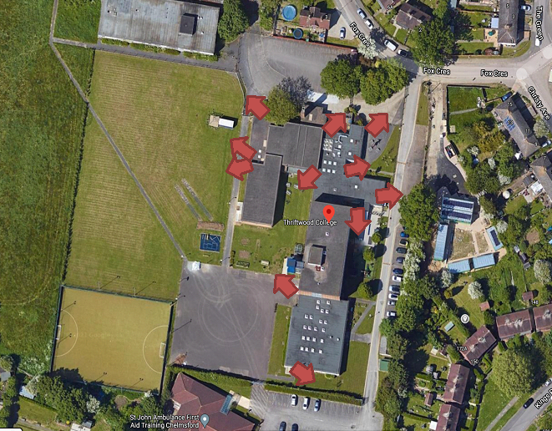

The system does not have sound recording capability.

The CCTV system is owned and operated by Thriftwood College, the deployment of which is determined by Thriftwood’s senior leadership team.

The CCTV is monitored by the Estate Manager on-site only.

The introduction of, or changes to, CCTV monitoring will be subject to consultation with staff and the college community.

The use of CCTV, and the associated images and any sound recordings is covered by the DPA. This policy outlines Thriftwood’s use of CCTV and how it complies with the legislation.

All authorised operators and employees with access to images are aware of the procedures that need to be followed when accessing the recorded images and sound. All operators are trained about their responsibilities under the CCTV policy. All employees are aware of the restrictions in relation to access to, and disclosure of, recorded images and sound.

Statement of Intent

Thriftwood complies with the Information Commissioner’s Office (ICO) CCTV Code of Practice to ensure it is used responsibly and safeguards both trust and confidence in its use. The Code of Practice is published at:

https://ico.org.uk/media/for-organisations/documents/1542/cctv-code-of-practice.pdf

CCTV warning signs will be clearly and prominently placed at the front, side and rear of the college building. Signs will contain details of the purpose for using CCTV (see Appendix A). In areas where CCTV is used, the college will ensure that there are prominent signs placed at both the entrance of the CCTV zone and within the controlled area.

The planning and design has endeavoured to ensure that the system will give maximum effectiveness and efficiency, but it is not possible to guarantee that the system will cover or detect every single incident taking place in the areas of coverage.

Siting the Cameras

Cameras will be sited so they only capture images relevant to the purposes for which they are installed, (as described above), and care will be taken to ensure that reasonable privacy expectations are not violated. The college will ensure that the location of equipment is carefully considered to ensure that images captured comply with the legislation.

The college will make every effort to position cameras so that their coverage is restricted to the college premises, which will include outdoor areas.

CCTV will not be used within college.

Members of staff should have access to details of where CCTV cameras are situated, with the exception of cameras placed for the purpose of covert monitoring.

Covert Monitoring

Thriftwood may in exceptional circumstances set up covert monitoring. For example:

- Where there is good cause to suspect an illegal or unauthorised action(s), is taking place, or where there are grounds to suspect serious misconduct;
- Where notifying the individuals about the monitoring would seriously prejudice the reason for making the recording.

In these circumstances authorisation must be obtained from a member of the senior leadership team.

Covert monitoring must cease following completion of an investigation.

Cameras sited for the purpose of covert monitoring will not be used in areas which are reasonably expected to be private, for example toilet cubicles.

Storage and Retention of CCTV Images

The college records images between the hours of 6.00pm on a Friday and 6.00am on a Monday during normal term-time. The college also records during similar hours over bank and public holidays and throughout holiday periods, i.e. whenever the premises are not manned by the Site Team and/or the Estate Manager is not on site.

Thriftwood retains CCTV images for 30 days. If there has been a disturbance during the recording period or if the premises/neighbouring premises have been subject to vandalism or a break-in, the college will hold the images for longer periods of time, as necessary, and share them with the police. Once checked, the images will be deleted by means of over-recording.

Access to CCTV Images

Access to recorded images will be restricted to those staff authorised to view them, and will not be made more widely available.

Subject Access Requests (SAR)

Individuals have the right to request access to CCTV footage relating to themselves under the GDPR.

All requests should be made in writing using the SAR request form to the Data Protection Lead. Individuals submitting requests for access will be asked to provide sufficient information to enable footage relating to them to be identified. For example, date, time and location.

Thriftwood will respond to requests within 1 calendar month of receiving the request.

Thriftwood reserves the right to refuse access to CCTV footage where this would prejudice the legal rights of other individuals or jeopardise an on-going investigation.

Please see the SEAX Trust Subject Access Request policy for further details.

Access to and Disclosure of Images to Third Parties

There will be no disclosure of recorded data to third parties other than to authorised personnel, such as the Police and service providers to the college where these would reasonably need access to the data (e.g. investigators). Requests by third parties should be assessed using the SEAX Trust Third Party Request for Information policy.

The data may be used within the college’s discipline and grievance procedures as required, and will be subject to the usual confidentiality requirements of those procedures.

Complaints

Complaints will be dealt with in accordance with the SEAX Trust Complaints Procedure.

Appendix A: CCTV Signage

It is a requirement of the Data Protection Act to notify people entering a CCTV protected area that the area is monitored by CCTV and that pictures are recorded. The college is to ensure that this requirement is fulfilled. The CCTV sign should include the following:

- That the area is covered by CCTV surveillance and pictures are recorded.
- The purpose of using CCTV.
- The name of the school/college.
- The contact telephone number or address for enquiries.

